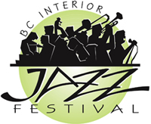

B.C. Interior Jazz Festival

Repertoire List

Name of Ensemble ________________________________________

Director(s) ________________________________________

Selection #1 ________________________________________

Composer/Arranger ________________________________________

Soloists (in order) instrument or voice part
- ________________________________ ____________________
- ________________________________ ____________________
- ________________________________ ____________________
- ________________________________ ____________________

Selection #2 ________________________________________

Composer/Arranger ________________________________________

Soloists (in order) instrument or voice part
- ________________________________ ____________________
- ________________________________ ____________________
- ________________________________ ____________________
- ________________________________ ____________________

Selection #3 ________________________________________

Composer/Arranger ________________________________________

Soloists (in order) instrument or voice part
- ________________________________ ____________________
- ________________________________ ____________________
- ________________________________ ____________________
- ________________________________ ____________________

*THREE SELECTIONS ONLY*

